TEAMS TEMPLATE:
Hi , this is XXX from IT team, this is regarding “INC0000”.
Please share your location details.
currently we are not having the accessory waiting for the stock.
we will hold this ticket and let you know once we received the accessory.

EMAIL TEMPLATE:
Dear User,
This is regarding the ticket- “INC0000”.
As per your request XXXXXXX is provided to you. Below you can find the Accessory related information.
Note: XXXX item is not provided.
Serial number: 79781015
Model: Jabra Evolve2 30 (wired)
Best regards
IT Support
REACHING THE USER THROUGH MAIL:
Dear User,

This is regarding the request – “INC0000”.

We are not able to reach you through MS Teams. We are holding the request for your response.
Please reach us JNX2KOR, once you are available to process your request.

Best regards
IT Support.

RESOLUTION TEMPLATE TO CLOSE AFTER 5 ATTEMPTS:
Dear
This is regarding ticket "INC0000"
We have made several attempts to contact you via Mail,
but unfortunately, we have been unsuccessful in reaching you.
we regret to inform you that we are closing this Ticket.
If you require any IT peripherals in the future, Kindly raise a new ticket via ITSP.
Link : https://service-management.bosch.tech/sp?id=search_itsp&spa=1&t=rsc&q=Small%20IT
Best Regards,
IT support.

CANCEL TICKET FORMAT:
Dear User,
This is regarding ticket "INC0000"
As per your confirmation we are cancelling this ticket. If you require any accessories in the future, please do not hesitate to raise a new ticket for small IT equipment via ITSP.
Thank you for your understanding.
Best Regards
IT support
DUPLICATE TICKET:
Dear User,
Regarding the incident: “INC0000”
As we checked, you already collected the request accessories for another ticket – “INC0000”. you informed us to close this ticket. Hence, we are closing this ticket as duplicate ticket.
Best Regards,
IT Support
10.Initiating a package which is not in SCCM: (Only for RBEI)
Dear (username)
This is regarding the ticket- “INC000000000000”.
The Requested software is not available in SCCM Environment, Kindly Drop an email to RBEI.LicenseMgmt@in.bosch.com, Third-Party Software Officer, Open Source Officer, to obtain the license. Please drop an email to them with your asset details.
Best regards
IT Support.

Currently we are experiencing entrust login issues. If you get any entrust related issues try the below workarounds.

Workaround: (Admin rights not required)

Open “Task Manger” and find the entrust related process, Then right click on “first entrust process” and click “end task”.
Open U-drive and copy the “PKI data” folder, Then move it to “C drive”.
Open the “PKI data” folder from C drive and run the “.epf” file.
Entrust login window will appear now, user has to enter the entrust/encryption password.
Now encryption will work.

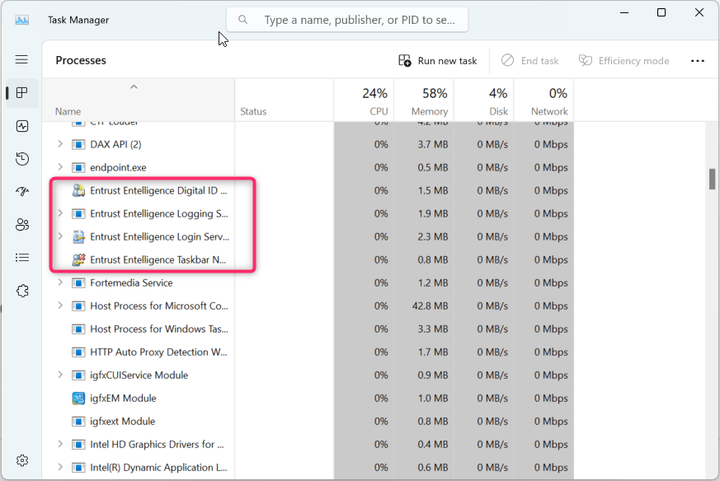
----------------------------------------------------------------------------
First mail
Dear XXXX,
This is regarding – RITMXXXX
Could you please return the computer – XXXXXX today.
Return Locations:
BANV-360 Room Number: L4-46.
KOR-905 building 2nd Floor Room Number: 227.
BANI-602 building 1st Floor Room: 120.
BMH2 (EC2) 2nd Floor Room number: 225
If there is no reply for first mail.
Dear XXXX,
Still, we are waiting for your response. Kindly return your computer – XXXX today.
Thanks,
If the agreed date is crossed.
Dear XXXX,
As per your update, computer is still not returned.
Kindly return your computer – XXXX today.
Thanks,
-------------------------------------------------------------------------------
Template, If user ask more than 8 days,
According to our service level agreement (SLA), associates are required to return their old devices to the IT team within 8 working days from the date of request created.
Kindly return the asset before XXXXX.
Thanks,
--------------------------------------------------------------------------------
Template for more than 8 days tickets.
Dear XXX,
I am writing to address the outstanding matter of the return device collection
According to our service level agreement (SLA), associates are required to return their old devices to the IT team within 8 working days from the date of request created. Unfortunately, this process has not yet been completed.
I kindly request that you submit the asset as soon as possible. If the device is not surrendered on time, a notification will be sent to the relevant department head.
Thank you for your attention to this matter.
RequesterDisplayName | TicketNumber | RequestedDate | CustomerUserId | ReturnDeviceName
Aravind M | TCK0000549897 | 08-Jan-25 | ARI3COB | COB1094056

Dear Shailesh,
If you want to buy, pls transfer the amount to below back details
Bank details
Beneficiary Name: BOSCH GLOBAL SOFTWARE TECHNOLOGIES PRIVATE LTD
Bank A/c No: 2028132000
Bank: Deutsche Bank AG
Account Type: Current
IFSC code: DEUT0797BGL
Branch: MG Road Branch, Bangalore
Next Steps
- Once payment is made share the details with a reply to this mail.
- GS/OBR (Anoop will confirm the receipt on BGSW bank Account)
- Sales order will be raised by Vikram,
- Invoice will be generated by LOG (Sakthi) and sent to you
- Asset will be removed from SAP (Shiva) & ASSENT (Monika) tool post Invoice is generated.
Best regards,
Ajay Anand
BGSW/CTG1

ServiceNow:
Citrix:
Service: BD-Virtual Workplace
Service offering: BD-Citrix Workspace App-Standard

Service : BD-Local additional support for end-devices
Service offering : BD-Local additional support for Printer

